

*Geophysical Research Letters*

Supporting Information for

**Bedrock erosion surfaces record former East Antarctic Ice Sheet extent**

Guy J. G. Paxman1*, Stewart S. R. Jamieson1, Fausto Ferraccioli2, Michael J. Bentley1, Neil Ross3, Egidio Armadillo4, Edward G. W. Gasson5, German Leitchenkov6,7, Robert M. DeConto8

1 Department of Geography, Durham University, Durham, UK

2 British Antarctic Survey, Cambridge, UK

3 School of Geography, Politics and Sociology, Newcastle University, Newcastle upon Tyne, UK

4 Dipartimento di Scienze della Terra, dell'Ambiente e della Vita, Università di Genova, Genova, Italy

5 Department of Geography, Sheffield University, Sheffield, UK

6 Institute for Geology and Mineral Resources of the World Ocean, St. Petersburg, Russia

7 St. Petersburg State University, St. Petersburg, Russia

8 Department of Geosciences, University of Massachusetts, Amherst, Massachusetts, USA

*Telephone: +44 191 334 3219; E-mail: guy.j.paxman@durham.ac.uk

**Contents of this file**

Text S1 to S6

Figures S1 to S8

Table S1

**Introduction**

This document contains details of the data used and the data processing (Text S1; Figure S1 and S2), the geomorphological analysis of the flat surfaces within the Wilkes Subglacial Basin (Text S2; Figure S3 and S4), and the 3D flexural modeling work (Text S3 to S6; Figure S5 to S8; Table S1).

**Text S1 – Radio-echo sounding bedrock elevation data acquisition and gridding**

The main aerogeophysical survey grid was flown over the northern WSB with a line spacing of 8.8 km and a tie line interval of 44 km. The survey comprised 68 flights, and acquired approximately 60,000 line kilometres of radio-echo sounding (RES), gravity and magnetic data. The survey was largely flown at 2350 m altitude, with exploratory lines flown at up to 3750 m. Differential GPS provided position to an accuracy of <5 cm. RES data were acquired using a coherent system with a 12 MHz bandwidth and 150 MHz carrier frequency, providing an approximate 10 m along-track sampling interval. Ice thickness was calculated from the two-way travel time of the bed pick using a velocity of 0.168 m ns−1 coupled with a firn layer correction of 10 m (Ferraccioli *et al.*, 2009; Jordan *et al.*, 2010, 2013). Bed elevations were then calculated by subtracting ice thickness measurements from ice surface elevations. Crossover analysis yields a standard deviation of ~33 m at crossovers between all intersecting flight tracks in the survey grid. The largest misfits are associated with the rugged topography of the Transantarctic Mountains. In the WSB, which is characterized by flatter and smoother topography (Figure S4), the standard deviation is ~10 m.

The bedrock elevation line data were interpolated onto a 1 km grid mesh using a continuous curvature spline algorithm (Wessel *et al.*, 2013) with a tension factor of 0.35. The resulting bedrock topography DEM was masked to remove any interpolated values more than 5 km from the nearest data point. For isostatic calculations that require a full DEM with no missing values, these data gaps were filled with data from Bedmap2 (Fretwell *et al.*, 2013). The bedrock DEM forms the basis for our geomorphological and geomorphometrical analysis of the topography, our estimation of bedrock erosion, and 3D flexural isostatic modelling used to reconstruct palaeo-elevations of the flat surfaces.

**Text S2 – Geomorphometry**

The bed slope grid was determined by computing the scalar magnitudes of the gradient vectors of the bedrock topography DEM51. The hypsometry (elevation-frequency distribution) of the flat surfaces was determined by assigning each bed elevation measurement point over the flat surfaces to one of 50 equally-spaced bins (corresponding to a bin width of ~40 m), as has been applied to other areas of the Antarctic ice sheet bed (Jamieson *et al.*, 2014). The elevation distribution was normalised to the total number of observations, such that the sum of the bar heights was 100%. Along-track basal roughness (*v*) was determined by computing the root mean squared (RMS) deviation (Shepard *et al.*, 2001) of the bedrock elevation, over a discrete length scale of 1600 m (Young *et al.*, 2011).

$$v\left(∆x\right)={\left[\frac{1}{N}\sum_{i=1}^{N}{{\left[z\left(x_{i}\right)-z\left(x_{i}+∆x\right)\right]}^{2}}\right]}^{\frac{1}{2}} (1)$$

where *z* is the bedrock elevation, *x* is the along track distance, and *Δx* is the step size between bed elevation measurements.

**Text S3 – Isostatic correction for ice sheet loading**.

We calculated the isostatic correction for the removal of the Antarctic Ice Sheet load using a model that calculates the flexure of a thin elastic plate (lithosphere) overlying an inviscid fluid (mantle), which represents an good approximation of the behaviour of the lithosphere over geological timescales (see Text S5) (Watts, 2001). We computed the isostatic adjustment associated with the removal of the entire grounded Antarctic Ice Sheet using the ice thickness grid from the Bedmap2 continental compilation (Fretwell *et al.*, 2013). We assumed typical densities for ice and mantle of 915 and 3330 kg m−3, respectively. The free parameter in the model is the effective elastic thickness of the lithosphere (*Te*). For simplicity, we use a uniform *Te* value of 35 km for the entire continent, reflecting a realistic average of East and West Antarctica (Wilson *et al.*, 2012). In reality, the width of the ice sheet (>1000 km) exceeds the typical flexural wavelength of the lithosphere. The result is that the ice sheet resides in approximate Airy (local) isostatic compensation (effective *Te* = 0 km) regardless of the rigidity of the lithosphere; the magnitude of the isostatic rebound due to ice sheet removal is insensitive to the chosen *Te* value.

After the removal of the ice sheet load, areas of the continent that lie below sea level will be flooded by the ocean. We calculated and subtracted the flexural response to the resulting water load in an iterative manner (Jamieson *et al.*, 2014) using a water density of 1030 kgm−3 and five iterations, after which the load changes were <2 m in magnitude. We assumed a uniform eustatic sea-level rise of 60 m to represent the addition of the Antarctic Ice Sheet to the global ocean, and accounted for the resulting change in geoid shape due to the change in the local gravity field associated with the melting of a large ice sheet mass (Whitehouse *et al.*, 2012). The flexural responses to ice sheet removal and water loading over the entire continent were summed, and added to the regional bedrock DEM to produce an isostatically rebounded topography in the absence of the AIS.

The viscoelastic nature of the mantle results in a delay of around 30 kyr between a change in the ice sheet load and the bedrock topography reaching a new isostatic equilibrium. Because isostatic equilibrium is not reached instantaneously, the adjusted bedrock topography reflects a time 30 kyr after the change in ice loading. For example, if the ice sheet were to retreat from its modern configuration to a retreated state such as that of the mid-Pliocene, the plateau surfaces would reside below sea level immediately after removal of the ice, and over a timescale of ca. 30 kyr would be uplifted to their final isostatic equilibrium position. However, the viscoelastic relaxation timescale is short compared to the timescales of erosion and surface planation, which typically require hundreds of thousands to millions of years to form such large erosional features (Wilson and Luyendyk, 2006). Therefore, the viscoelastic delay does not significantly affect our reconstructed bedrock elevations or estimated timing of surface planation, since the planation surfaces would spend comparatively little time close to sea level during post-14 Ma glacial-interglacial cycles compared to the protracted period between 34 and 14 Ma.

**Text S4 – Estimation of glacial erosion and sediment distribution**.

A 3D erosion restoration model was applied in order to correct the bedrock elevation for the isostatic response to glacial incision beneath the EAIS. The distribution of eroded material was estimated using a peak accordance method, as has been used in a number of settings in Antarctica and globally (Stern, Baxter and Barrett, 2005; Champagnac *et al.*, 2007; Paxman *et al.*, 2016). This approach is based on the assumption that the pre-incision topography can be represented by a continuous low relief surface that subsequently experienced incision, and the bedrock plateaus are the remnants of this surface. We also used a circular sliding window (with a radius of 10 km) (Champagnac *et al.*, 2007) to identify local topographic highs in regions of the DEM where there are no plateau surfaces (e.g. in the Transantarctic Mountains). We then interpolated a smooth surface between the plateau surfaces and other local topographic highs (i.e. mountain peaks) using a continuous curvature spline with a tension factor of 0.5 (Wessel *et al.*, 2013). The interpolation between the ‘accordant peaks’ was carried out at 5 km horizontal resolution, and produced a smooth ‘peak accordance surface’ (Figure S5). This method assumes that the relic flat surfaces have not experienced significant glacial erosion. The 3D distribution of eroded material was determined by subtracting the bedrock DEM (Figure 1) from the peak accordance surface.

Offshore sediment thickness grids determined from seismic reflection data were used to compute the effect of offshore sediment loading. The estimated volume of onshore eroded material was 2.5x105 km3, and the volume of post-34 Ma offshore sediments was 4.3x105 km3. These volumes correspond to masses of ~6x105 Gt (Gigatonnes; 1012 kg) of eroded material, assuming an average eroded rock density of 2500 kg m–3 (a realistic average of Beacon Supergroup sedimentary rocks and Ferrar dolerites (Ferraccioli *et al.*, 2009)) and 7–9x105 Gt of shelf sediment, assuming offshore sediment densities of 1950–2150 kg m–3 and 5–15% biogenic (non-detrital) content (Wilson *et al.*, 2012). These values are in reasonable agreement, indicating that our erosion model is robust to first order.

Ordinarily, the peak accordance method yields a minimum estimate of erosion, since it assumes that the accordant peaks have not been lowered over the time frame being considered (Champagnac *et al.*, 2007). However, in this instance the estimated eroded volume may be an overestimate, since the Eastern, Central and Western Basins of the WSB are likely superimposed on pre-existing fault systems (Ferraccioli *et al.*, 2009; Jordan *et al.*, 2013). A component basin-floor lowering may therefore be attributable to tectonic subsidence due to motion on these fault systems. However, the majority of basin-floor lowering is likely due to erosion rather than tectonic subsidence for a number of reasons. Firstly, there is no evidence for major post-34 Ma tectonic activity or crustal thinning in the WSB. Secondly, the volume of post-34 Ma WSB-derived sediment offshore is sufficient to account for the amount of ‘missing’ eroded material onshore, even assuming trough depths are entirely the result of erosion. Finally, in the Lambert Graben system, which is an analogue for the glacially overdeepened, tectonically controlled troughs of the WSB, thermochronology, flexural modelling and geological evidence suggest that almost the entirety of trough floor lowering and flank uplift are attributable to post-34 Ma glacial erosion and the associated flexural response (Hambrey and McKelvey, 2000; Hambrey *et al.*, 2007; Tochilin *et al.*, 2012; Thomson *et al.*, 2013; Paxman *et al.*, 2016).

**Text S5 – Flexural response to erosion and sedimentation**. The flexural response of the lithosphere to erosional unloading and sediment loading was computed using an isostatic model that calculates the flexural adjustment (*w*) to loading of a thin elastic plate overlying an inviscid fluid (Watts, 2001)

$$D∇^{4}w\left(x,y\right)+\left(ρ_{mantle}-ρ_{infill}\right)gw\left(x,y\right)=\left(ρ_{load}-ρ_{displace}\right)gh\left(x,y\right)$$

where

$$D=\frac{E{T_{e}}^{3}}{12 (1-ν^{2})}$$

is the flexural rigidity of the lithosphere, which is assumed to be spatially constant, *E* = 100 GPa is Young’s modulus, *v* = 0.25 is the Poisson ratio, and *Te* is the effective elastic thickness of the lithosphere. The magnitude of the vertical load is given by *h*, and the loading effect was determined using the acceleration due to gravity (*g* = 9.81 m s–2) and the densities of the load (*ρload*), mantle (*ρmantle*), and material infilling and displaced by the flexure (*ρinfill* and *ρdisplace*). The flexure (*w*) due to erosional unloading and sediment loading was computed assuming a uniform *Te* of 35 km, an eroded rock density of 2500 kg m−3, sediment density of 2000 kg m−3 and water density of 1030 kg m−3. The 34 Ma topography of the WSB was reconstructed by filling the basins with the eroded material, and removing the flexural responses to erosional unloading and sediment loading since 34 Ma.

**Text S6 – Erosion chronology.** In order to reconstruct the elevation of the planation surfaces at the time slices of interest, an approximate temporal history of glacial erosion was established. IODP drill cores (Escutia, Brinkhuis and Klaus, 2011; Tauxe *et al.*, 2012) and un-published offshore sediment thickness estimates from Russian seismic lines indicate that ∼70% of the glacial (post-34 Ma) sediment had been deposited by 14 Ma, and ~90% by 3 Ma (Figure S6), and that long-term (million year average) sedimentation rates were approximately linear between these times. We therefore assume that 70% of the total source area glacial erosion (and concomitant flexural uplift) occurred between 34 and 14 Ma, a further 20% occurred between 14 and 3 Ma, and the remaining 10% between 3 Ma and the present-day. This temporal model is used in our paleo-elevation reconstructions (e.g. Figure S7). This chronology indicates that erosion rates decreased by a factor of ~2 following the mid-Miocene transition at ca. 14 Ma. This slowdown in glacial erosion rates at 14 Ma is also indicated by detrital thermochronology in the Lambert Glacier catchment to the west (Tochilin *et al.*, 2012; Thomson *et al.*, 2013). Geological constraints (uplifted Oligocene–Neogene fjordal sediments) and flexural models that constrain the history of erosion-driven isostatic uplift in the Lambert Glacier region also support this slowdown in erosion-driven uplift rates at ca. 14 Ma (Hambrey and McKelvey, 2000; Hambrey *et al.*, 2007; Paxman *et al.*, 2016). Our estimated history of glacial erosion, offshore sedimentation, and flexural uplift/subsidence since 34 Ma is shown in Table S1.

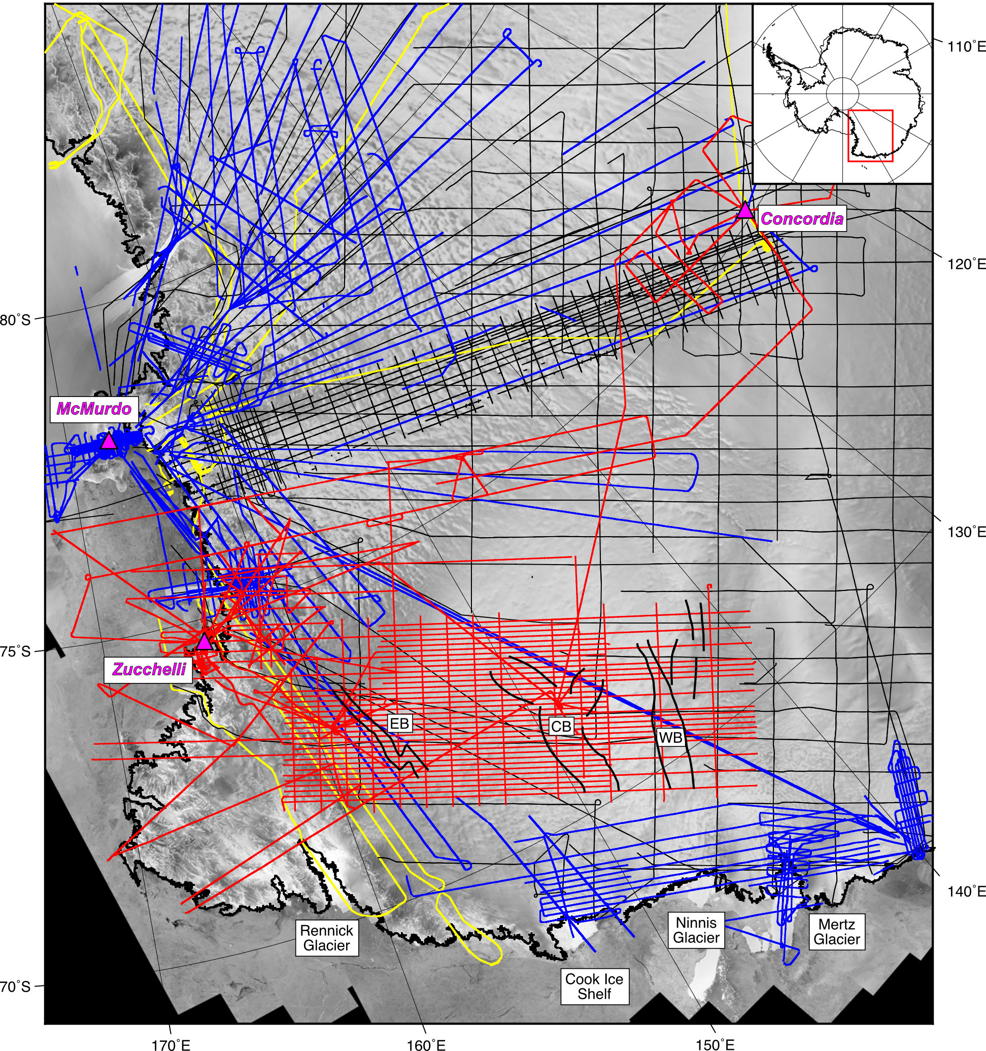

**Figure S1.** Airborne geophysical data coverage over the Wilkes Subglacial Basin.Displayed are aircraft flight paths for the 2005/06 WISE-ISODYN survey (red), 2009–12 ICECAP field campaigns (blue), Operation IceBridge flights (yellow), the 1999 WLK corridor survey (thick black), and radio-echo sounding surveys completed by the SPRI-NSF-TUD consortium (thin black). The solid lines in the northern WSB show the margins of the major sub-basins (Ferraccioli *et al.*, 2009). Abbreviations: CB = Central Basin; EB = Eastern Basin; WB = Western Basin.

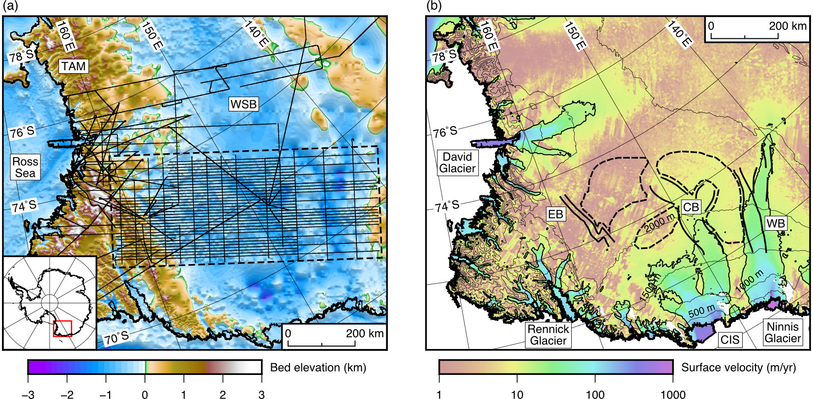

**Figure S2**. Regional setting of the Wilkes Subglacial Basin in East Antarctica. (a) Bed topography of the WSB region (Fretwell *et al.*, 2013) and aerogeophysical survey flight lines (black) (Ferraccioli *et al.*, 2009); dashed box shows the main survey grid. (b) Ice surface velocity with the 25 m/yr contour shown. Selected ice surface elevation contours (Fretwell *et al.*, 2013) are labeled. Sub-basin outlines are marked by the solid lines. Plateau surface remnants are shown by the dashed line outlines. Abbreviations: CB = Central Basin; CIS = Cook Ice Shelf; EB = Eastern Basin; TAM = Transantarctic Mountains; WB = Western Basin; WSB = Wilkes Subglacial Basin.

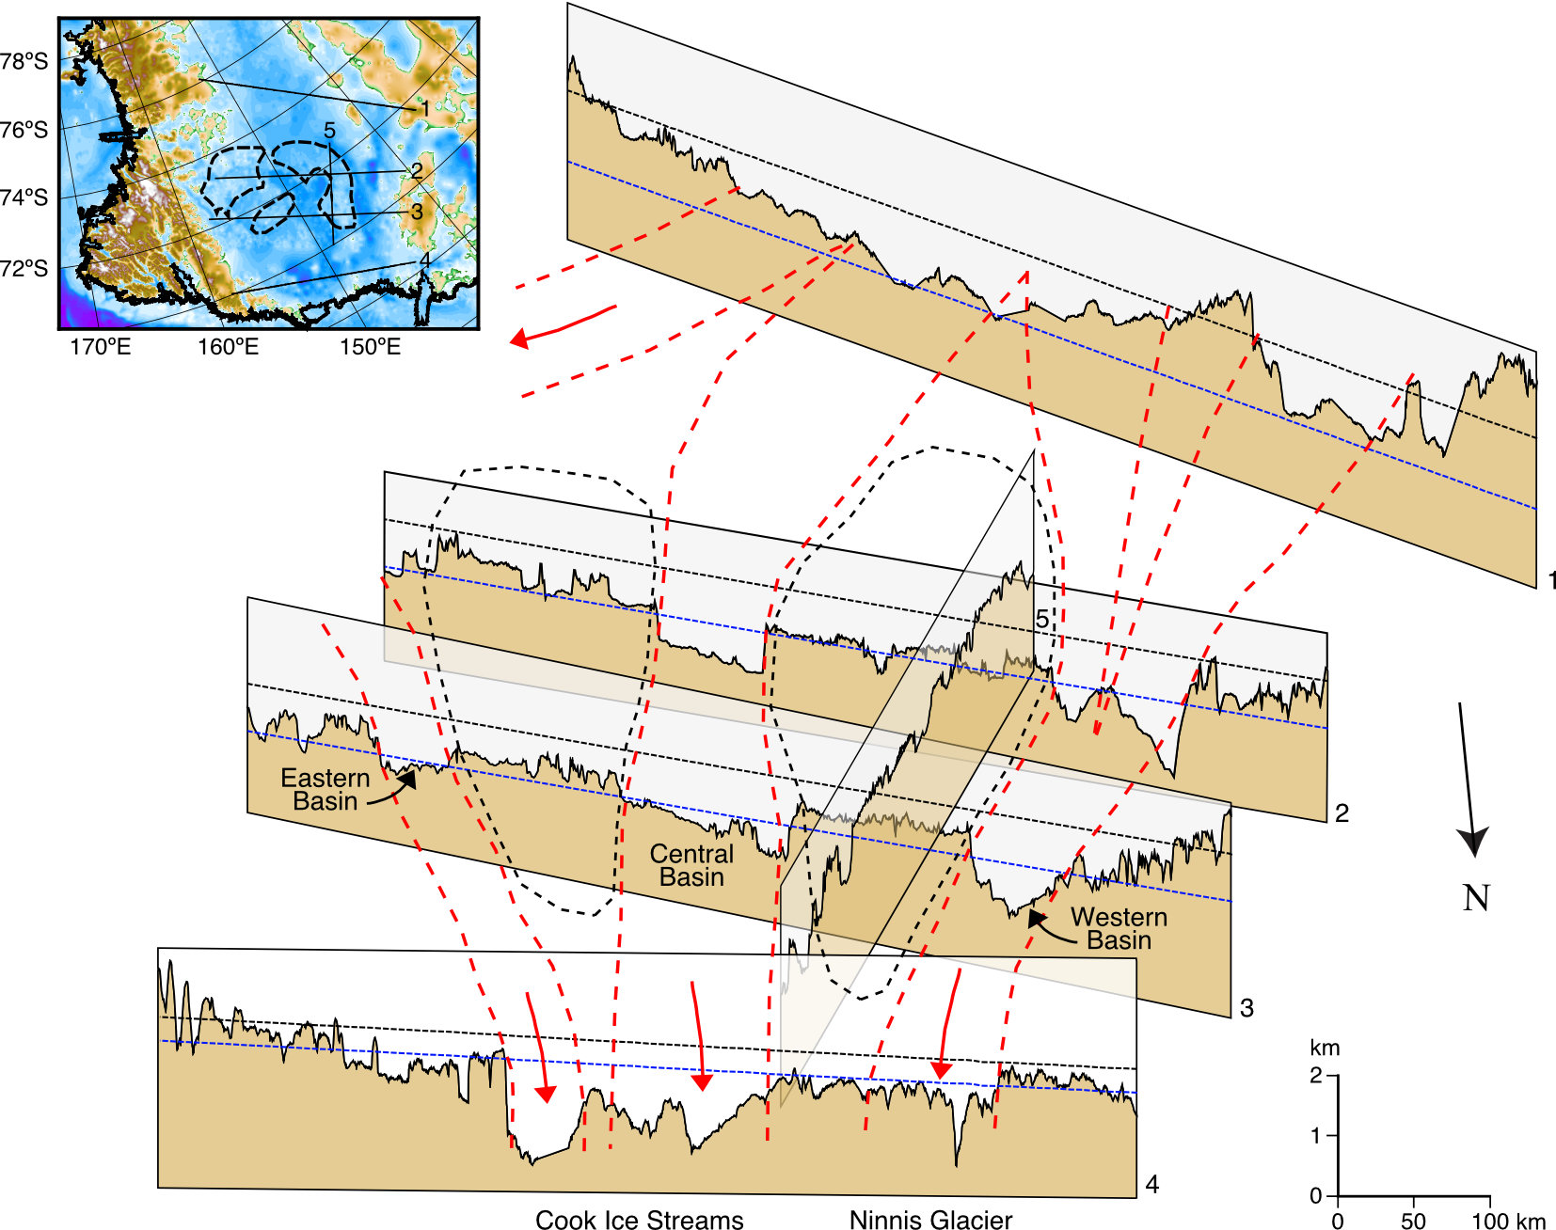

**Figure S3**. Variation of bedrock topography along the Wilkes Subglacial Basin.Schematic diagram showing bedrock topography derived from four RES lines crossing the WSB and one tie line. Inset shows the location of the five flight lines superimposed on Bedmap2 (Fretwell *et al.*, 2013). Flight lines are from the ICECAP (1 and 4) and WISE-ISODYN (2, 3 and 5) surveys. Thin dashed lines indicate sea level under modern (black) and ice-free (blue) conditions. The approximate direction of fast ice flow through the troughs is marked by red dashed lines, with arrows indicating flow direction. Ice flow is from south to north and is topographically controlled. The ice is diverted around the flat bedrock plateau surfaces observed in lines 2, 3 and 5. The profiles show that these flat surfaces are confined to the central-to-northern parts of the basin. Dashed black lines mark the mapped extent of the plateau surfaces. To the south, the basin is defined by a single, long-wavelength depression (line 1). Ice flowing through the Eastern and Central Basins converges near the coast to form ice streams that drain into the Cook Ice Shelf (Figure S1). Ice flowing through the Western Basin drains into the Ninnis Glacier (Figure S1). Inset shows the location of the RES profiles. Plateau surface remnants are shown by the dashed line outlines.

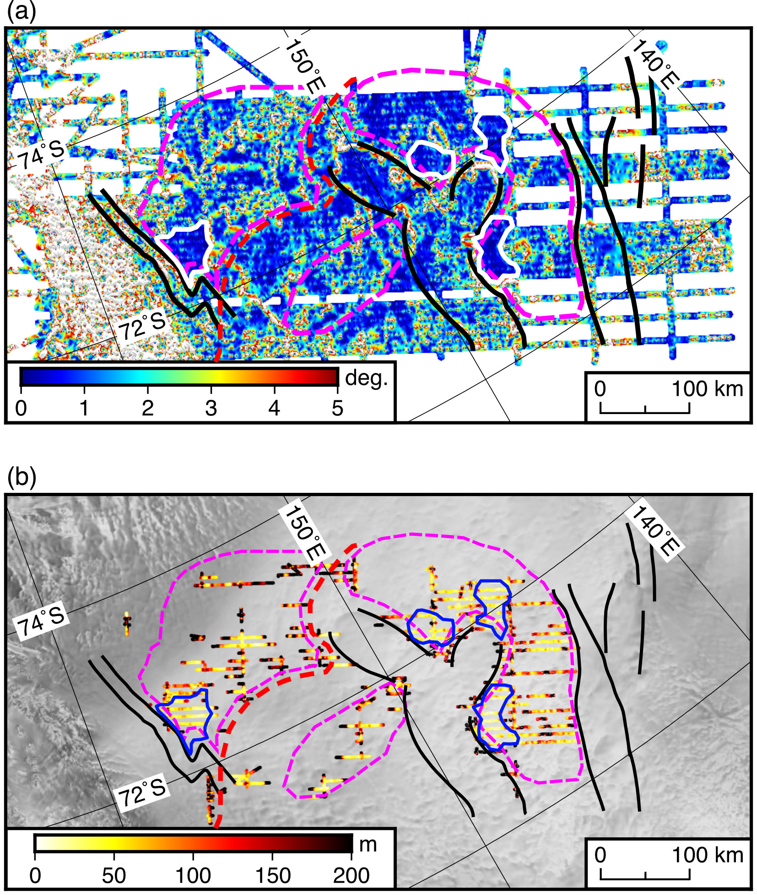

**Figure S4**. Plateau surface geomorphometry. (a) Slope of subglacial topography. White polygons indicate areas of the plateau surfaces with a particularly low slope (<1º). (b) Along-track basal roughness (bed elevation RMS deviation (Shepard *et al.*, 2001)) of the plateau surfaces. Blue polygons indicate areas of low basal roughness (<50 m), corresponding to areas of low slope. Red dashed line marks break of slope. Black lines mark sub-basin outlines. Magenta dashed lines show outlines of plateau surface remnants. Figure location is the same as in Figure 2c in the main manuscript.

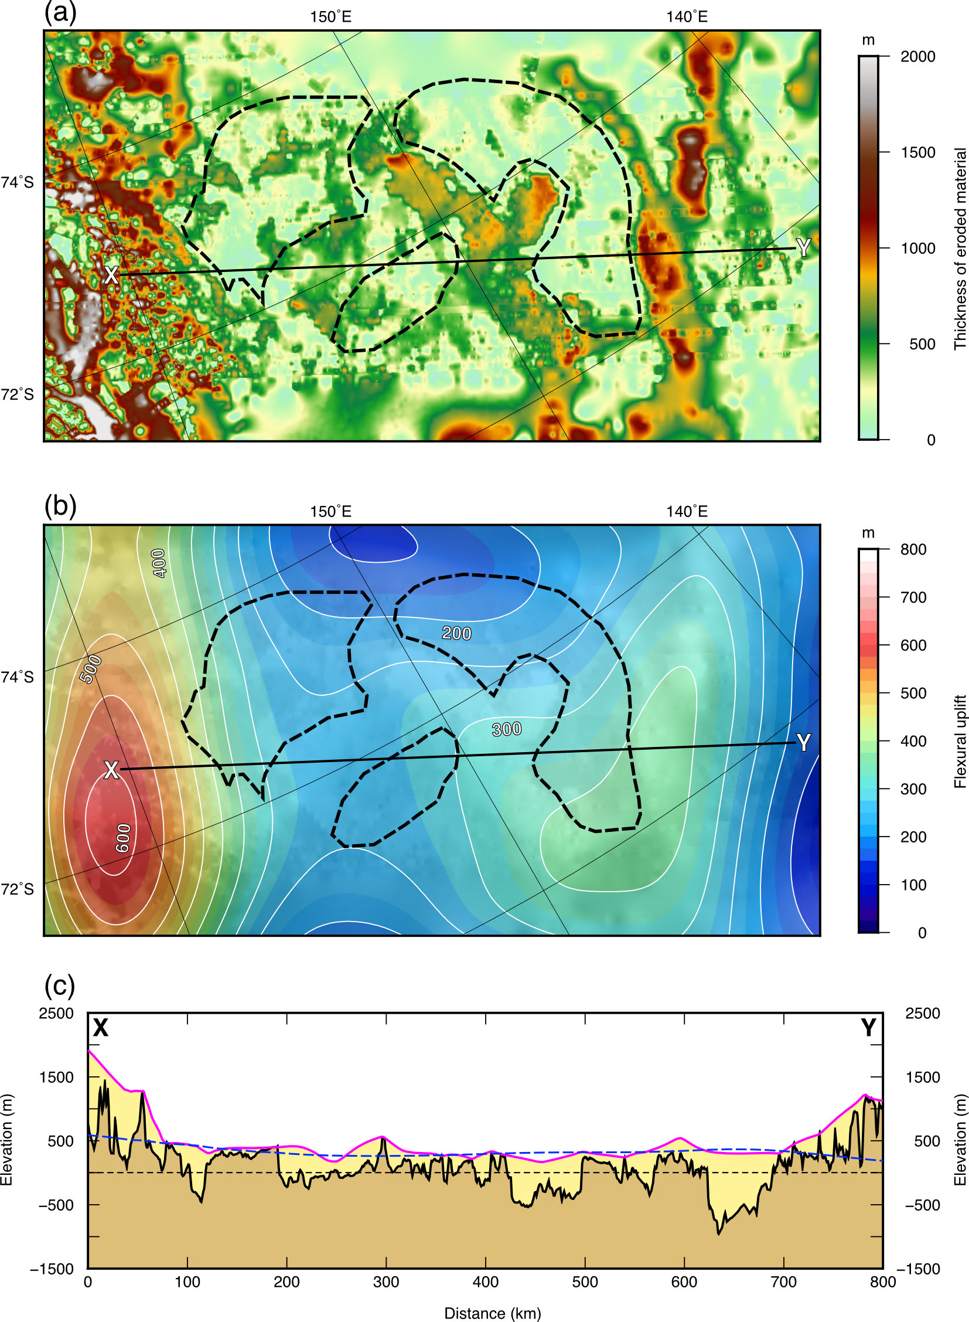

**Figure S5**. Estimation of glacial erosion within the Wilkes Subglacial Basin and the associated flexural response. (a) Estimated thickness of eroded material. Panel extent is the same as in Figure 2c in the main manuscript. Plateau surface remnants are shown by the dashed line outlines. (b) Computed amount of flexural uplift resulting from the removal of the eroded material from an elastic plate above a non-viscous fluid mantle. Contour interval is 50 m and contour labels are in meters. Plateau surface remnants are shown by the dashed line outlines. (c) Profile X–Y (location marked in panels a and b) showing the bedrock topography (black line) and amount of erosion across the WSB. The magenta line shows the peak accordance surface, which joins pre-incision ‘accordant’ surfaces observed in the bedrock topography. The yellow region is the eroded material. Dashed blue line shows the computed amount of flexural uplift associated with erosional unloading. The amount of flexure varies from 600 m over the edge of the TAM to 250–350 m across the WSB.

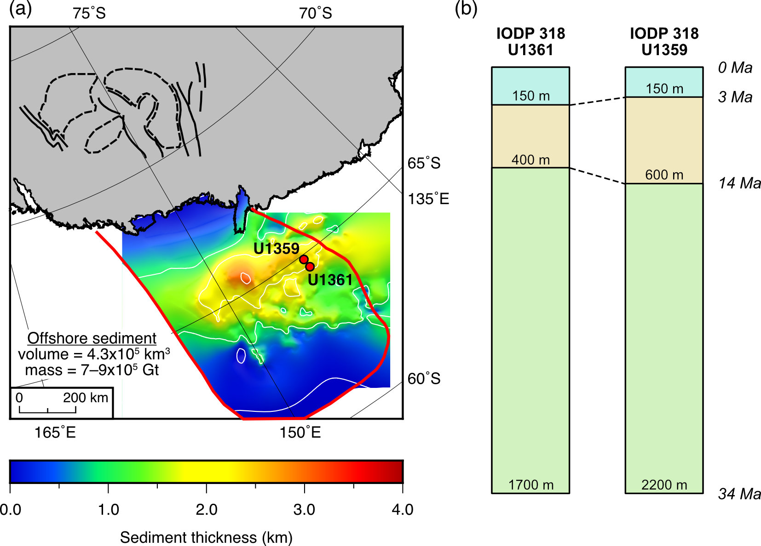

**Figure S6**. Offshore sedimentation on the Wilkes Land margin. (a) Offshore post-34 Ma sediment thickness estimates derived from seismic reflection data. The total mass of glacial sediment is in good agreement with our estimated mass of glacially-eroded material. Black lines mark sub-basin outlines. Dashed lines show outlines of plateau surface remnants. (b) Schematic of sediment thicknesses in IODP (Leg 318) drill cores (locations shown by red circles in panel a). Down-core depths of the boundaries between sediment packages (34–14 Ma, 14–3 Ma, and 3–0 Ma) are labelled.

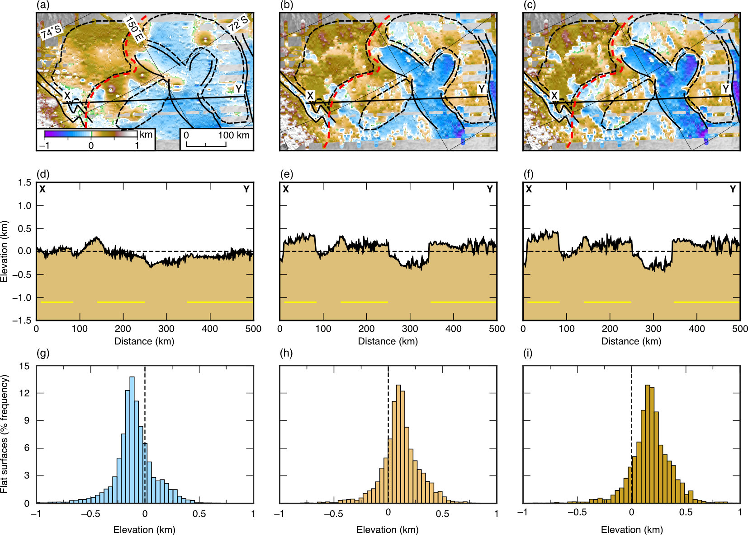

**Figure S7**. Plateau surface palaeo-elevation reconstruction. (a) Eocene–Oligocene Boundary (34 Ma), (b) mid-Miocene (14 Ma), and (c) mid-Pliocene (3 Ma) reconstructed bedrock elevations. Black lines show sub-basin outlines (Ferraccioli *et al.*, 2009). Red dashed line shows the break of slope. Plateau surface remnants are shown by the dashed line outlines. White lines denote the sea level (0 m) contour. Panel extent is the same as in Figure 3 in the main manuscript. (d), (e), and (f) show the corresponding bedrock elevations at each time interval along the profile X–Y, crossing the plateau surfaces and overdeepened sub-basins. Yellow lines indicate plateau surfaces. (g), (h), and (i) show the corresponding bedrock hypsometry distributions of the plateau surfaces for each time interval. Elevations in all time intervals are under ice-free conditions. As the basins are progressively overdeepened, the flexural response of the lithosphere to erosional unloading drives uplift of the intervening plateau surfaces.

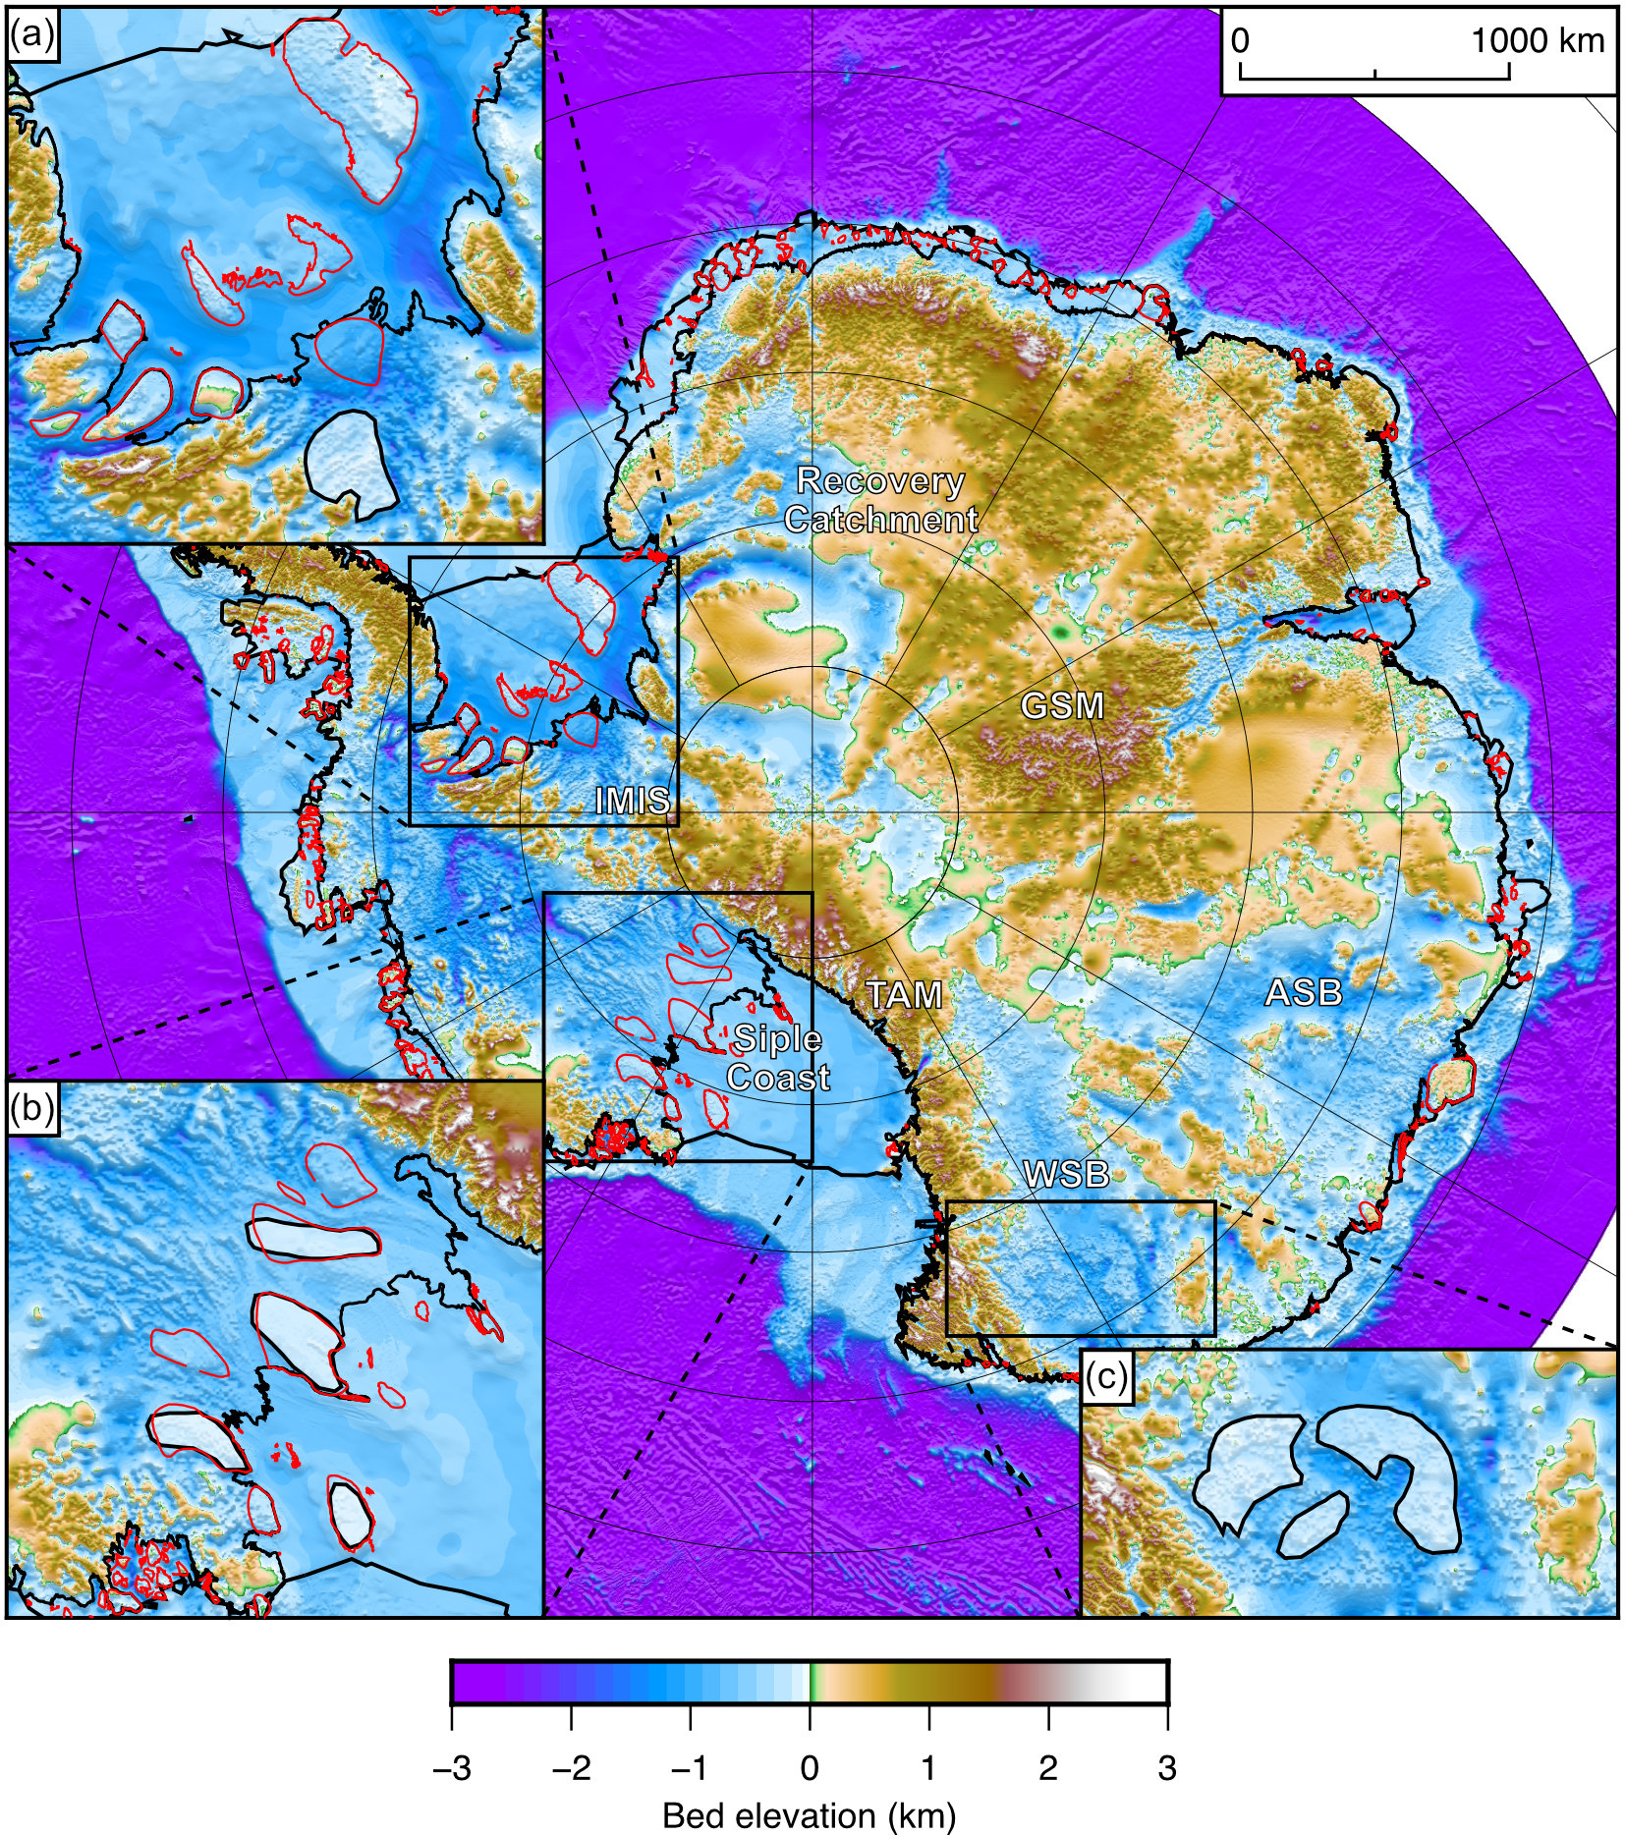

**Figure S8**. Ice rises and bedrock plateaus/platforms around the Antarctic margin. Bedrock topography of Antarctica (Fretwell *et al.*, 2013), with present-day ice rises and rumples shown in red (Matsuoka *et al.*, 2015). (a) Weddell Sea Embayment and the Institute and Moller Ice Streams (IMIS). Bedrock planation surfaces shown by semi-transparent white polygon with solid outline (Rose *et al.*, 2015). (b) Siple Coast ice rises (red) and bedrock platforms (white polygons) within the Ross Sea Embayment (Wilson and Luyendyk, 2006). (c) Wilkes Subglacial Basin (WSB) plateau surfaces. All three sets of plateau surfaces exhibit similar bedrock elevations (~200–800 m below sea level) and horizontal extents. All three inset panels are shown at the same horizontal scale, and are magnified from the main image by a factor of two. Abbreviations: ASB = Aurora Subglacial Basin; GSM = Gamburtsev Subglacial Mountains; IMIS = Institute and Moller Ice Streams; TAM = Transantarctic Mountains.

**Table S1**. Elevation history of the planation surfaces. Estimated amount of vertical displacement experienced by the planation surfaces within the WSB over the past 34 Ma. The estimated modal planation surface elevations over this time period indicate that the surfaces were situated close to sea level in the Oligocene–early Miocene, and have been uplifted by approximately 300 m since the Eocene–Oligocene Boundary. Also indicated are average isostatic uplift rates of the planation surfaces.

|  |  |  |  |  |
| --- | --- | --- | --- | --- |
| Time | Amount of vertical displacement (m) of the planation surfaces compared to position at the Eocene–Oligocene Boundary | | Modal elevation of the planation surfaces when free of ice cover (relative to present-day sea level) (m) | Average isostatic uplift rate of the planation surfaces (m/Myr) |
| Ice loading | Erosional unloading |
| Eocene–Oligocene Boundary (34 Ma) | 0 | 0 | –100 |  |
| mid-Miocene (14 Ma) | 0 | +210 | 110 | 10.5 (34–14 Ma) |
| mid-Pliocene (3 Ma) | 0 | +270 | +170 | 5.45 (14–3 Ma) |
| Modern (0 Ma) | –750 | +300 | –550 (beneath modern ice sheet)  +200 (if isostatically rebounded for present-day ice loading) | 10.0 (3–0 Ma) |

**References**

Champagnac, J. D., Molnar, P., Anderson, R. S., Sue, C. and Delacou, B. (2007) ‘Quaternary erosion-induced isostatic rebound in the western Alps’, *Geology*, 35(3), pp. 195–198. doi: 10.1130/G23053A.1.

Escutia, C., Brinkhuis, H. and Klaus, A. (2011) ‘IODP Expedition 318: From Greenhouse to Icehouse at the Wilkes Land Antarctic Margin’, *Scientific Drilling*, 12, pp. 15–23. doi: 10.2204/iodp.sd.12.02.2011.

Ferraccioli, F., Armadillo, E., Jordan, T., Bozzo, E. and Corr, H. (2009) ‘Aeromagnetic exploration over the East Antarctic Ice Sheet: A new view of the Wilkes Subglacial Basin’, *Tectonophysics*, 478(1–2), pp. 62–77. doi: 10.1016/j.tecto.2009.03.013.

Fretwell, P., Pritchard, H. D., Vaughan, D. G., Bamber, J. L., Barrand, N. E., Bell, R., Bianchi, C., Bingham, R. G., Blankenship, D. D., Casassa, G., Catania, G., Callens, D., Conway, H., Cook, A. J., Corr, H. F. J., Damaske, D., Damm, V., Ferraccioli, F., Forsberg, R., Fujita, S., Gim, Y., Gogineni, P., Griggs, J. A., Hindmarsh, R. C. A., Holmlund, P., Holt, J. W., Jacobel, R. W., Jenkins, A., Jokat, W., Jordan, T., King, E. C., Kohler, J., Krabill, W., Riger-Kusk, M., Langley, K. A., Leitchenkov, G., Leuschen, C., Luyendyk, B. P., Matsuoka, K., Mouginot, J., Nitsche, F. O., Nogi, Y., Nost, O. A., Popov, S. V., Rignot, E., Rippin, D. M., Rivera, A., Roberts, J., Ross, N., Siegert, M. J., Smith, A. M., Steinhage, D., Studinger, M., Sun, B., Tinto, B. K., Welch, B. C., Wilson, D., Young, D. A., Xiangbin, C. and Zirizzotti, A. (2013) ‘Bedmap2: improved ice bed, surface and thickness datasets for Antarctica’, *The Cryosphere*, 7(1), pp. 375–393. doi: 10.5194/tc-7-375-2013.

Hambrey, M. J., Glasser, N., Mckelvey, B., Sugden, D. and Fink, D. (2007) ‘Cenozoic landscape evolution of an East Antarctic oasis (Radok Lake area, northern Prince Charles Mountains), and its implications for the glacial and climatic history of Antarctica’, *Quaternary Science Reviews*, 26(5–6), pp. 598–626. doi: 10.1016/j.quascirev.2006.11.014.

Hambrey, M. J. and McKelvey, B. (2000) ‘Major Neogene fluctuations of the East Antarctic ice sheet: Stratigraphic evidence from the Lambert Glacier region’, *Geology*, 28(10), pp. 887–890. doi: 10.1130/0091-7613(2000)28<887:MNFOTE>2.0.CO;2.

Jamieson, S. S. R., Stokes, C. R., Ross, N., Rippin, D. M., Bingham, R. G., Wilson, D. S., Margold, M. and Bentley, M. J. (2014) ‘The glacial geomorphology of the Antarctic ice sheet bed’, *Antarctic Science*, 26(6), pp. 724–741. doi: 10.1017/S0954102014000212.

Jordan, T. A., Ferraccioli, F., Armadillo, E. and Bozzo, E. (2013) ‘Crustal architecture of the Wilkes Subglacial Basin in East Antarctica, As revealed from airborne gravity data’, *Tectonophysics*, 585, pp. 196–206. doi: 10.1016/j.tecto.2012.06.041.

Jordan, T. A., Ferraccioli, F., Corr, H., Graham, A., Armadillo, E. and Bozzo, E. (2010) ‘Hypothesis for mega-outburst flooding from a palaeo-subglacial lake beneath the East Antarctic Ice Sheet’, *Terra Nova*, 22(4), pp. 283–289. doi: 10.1111/j.1365-3121.2010.00944.x.

Matsuoka, K., Hindmarsh, R. C. A., Moholdt, G., Bentley, M. J., Pritchard, H. D., Brown, J., Conway, H., Drews, R., Durand, G., Goldberg, D., Hattermann, T., Kingslake, J., Lenaerts, J. T. M., Martín, C., Mulvaney, R., Nicholls, K. W., Pattyn, F., Ross, N., Scambos, T. and Whitehouse, P. L. (2015) ‘Antarctic ice rises and rumples: Their properties and significance for ice-sheet dynamics and evolution’, *Earth-Science Reviews*, 150, pp. 724–745. doi: 10.1016/j.earscirev.2015.09.004.

Paxman, G. J. G., Watts, A. B., Ferraccioli, F., Jordan, T. A., Bell, R. E., Jamieson, S. S. R. and Finn, C. A. (2016) ‘Erosion-driven uplift in the Gamburtsev Subglacial Mountains of East Antarctica’, *Earth and Planetary Science Letters*, 452, pp. 1–14. doi: 10.1016/j.epsl.2016.07.040.

Rose, K. C., Ross, N., Jordan, T. A., Bingham, R. G., Corr, H. F. J., Ferraccioli, F., Le Brocq, A. M., Rippin, D. M. and Siegert, M. J. (2015) ‘Ancient pre-glacial erosion surfaces preserved beneath the West Antarctic Ice Sheet’, *Earth Surface Dynamics*, 3(1), pp. 139–152. doi: 10.5194/esurf-3-139-2015.

Shepard, M. K., Campbell, B. A., Bulmer, M. H., Farr, T. G., Gaddis, L. R. and Plaut, J. J. (2001) ‘The roughness of natural terrain: A planetary and remote sensing perspective’, *Journal of Geophysical Research: Planets*, 106(E12), pp. 32777–32795. doi: 10.1029/2000JE001429.

Stern, T. A., Baxter, A. K. and Barrett, P. J. (2005) ‘Isostatic rebound due to glacial erosion within the Transantarctic Mountains’, *Geology*, 33(3), pp. 221–224. doi: 10.1130/G21068.1.

Tauxe, L., Stickley, C. E., Sugisaki, S., Bijl, P. K., Bohaty, S. M., Brinkhuis, H., Escutia, C., Flores, J. A., Houben, A. J. P., Iwai, M., Jiménez-Espejo, F., McKay, R., Passchier, S., Pross, J., Riesselman, C. R., Rhl, U., Sangiorgi, F., Welsh, K., Klaus, A., Fehr, A., Bendle, J. A. P., Dunbar, R., Gonzlez, J., Hayden, T., Katsuki, K., Olney, M. P., Pekar, S. F., Shrivastava, P. K., Van De Flierdt, T., Williams, T. and Yamane, M. (2012) ‘Chronostratigraphic framework for the IODP Expedition 318 cores from the Wilkes Land Margin: Constraints for paleoceanographic reconstruction’, *Paleoceanography*, 27(2), pp. 1–19. doi: 10.1029/2012PA002308.

Thomson, S. N., Reiners, P. W., Hemming, S. R. and Gehrels, G. E. (2013) ‘The contribution of glacial erosion to shaping the hidden landscape of East Antarctica’, *Nature Geoscience*, 6(3), pp. 203–207. doi: 10.1038/ngeo1722.

Tochilin, C. J., Reiners, P. W., Thomson, S. N., Gehrels, G. E., Hemming, S. R. and Pierce, E. L. (2012) ‘Erosional history of the Prydz Bay sector of East Antarctica from detrital apatite and zircon geo- and thermochronology multidating’, *Geochemistry, Geophysics, Geosystems*, 13(11), pp. 1–21. doi: 10.1029/2012GC004364.

Watts, A. B. (2001) *Isostasy and Flexure of the Lithosphere*. Cambridge: Cambridge University Press.

Wessel, P., Smith, W. H. F., Scharroo, R., Luis, J. and Wobbe, F. (2013) ‘Generic Mapping Tools: Improved Version Released’, *Eos, Transactions American Geophysical Union*, 94(45), pp. 409–410. doi: 10.1002/2013EO450001.

Whitehouse, P. L., Bentley, M. J., Milne, G. A., King, M. A. and Thomas, I. D. (2012) ‘A new glacial isostatic adjustment model for Antarctica: Calibrated and tested using observations of relative sea-level change and present-day uplift rates’, *Geophysical Journal International*, 190(3), pp. 1464–1482. doi: 10.1111/j.1365-246X.2012.05557.x.

Wilson, D. S., Jamieson, S. S. R., Barrett, P. J., Leitchenkov, G., Gohl, K. and Larter, R. D. (2012) ‘Antarctic topography at the Eocene-Oligocene boundary’, *Palaeogeography, Palaeoclimatology, Palaeoecology*, 335–336, pp. 24–34. doi: 10.1016/j.palaeo.2011.05.028.

Wilson, D. S. and Luyendyk, B. P. (2006) ‘Bedrock platforms within the Ross Embayment, West Antarctica: Hypotheses for ice sheet history, wave erosion, Cenozoic extension, and thermal subsidence’, *Geochemistry, Geophysics, Geosystems*, 7(12), pp. 1–23. doi: 10.1029/2006GC001294.

Young, D. A., Wright, A. P., Roberts, J. L., Warner, R. C., Young, N. W., Greenbaum, J. S., Schroeder, D. M., Holt, J. W., Sugden, D. E., Blankenship, D. D., van Ommen, T. D. and Siegert, M. J. (2011) ‘A dynamic early East Antarctic Ice Sheet suggested by ice-covered fjord landscapes’, *Nature*, 474(7349), pp. 72–75. doi: 10.1038/nature10114.